**Experiment 4:**

**Title:** Crimping of Unshielded Twisted Pair cable and check the performance. (Cat-6)

**Introduction:**

An unshielded twisted pair cable (or UTP), more commonly referred to as Ethernet cable, is used to connect devices to networking equipment such as routers or switches. While you can buy premade UTP cables from office supply chains or computer stores it can be more cost-efficient to cut and crimp your own cable if you have a large number of devices that need to be networked together. With a specialized crimping tool you can easily make as many UTP cables as you need in a short amount of time.

**Procedure:**

Measure out the distance between the networking device and the machine it will be connected to, such as a computer or printer. Get a portion of UTP cable that is at least two inches longer than the length you measured out to make room for going around corners or other devices.

Thread one inch of either end of the UTP cable into the stripping hole on the wire crimping tool. Push down on the tool and slide it off the cable to remove the plastic sheath around the inner cabling. Untwist all of the colored cables inside the plastic sheath.

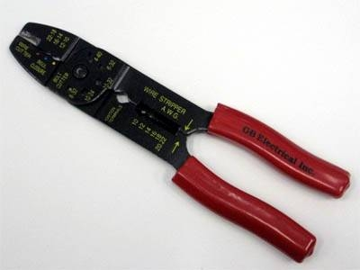

Line up the colored wires in the pattern you need for the devices you will be connecting together. Line up the colors in this order: white and green; green, white and orange; blue, white and blue; orange, white and brown; and then brown if you will be connecting a device to a switch, router or hub.

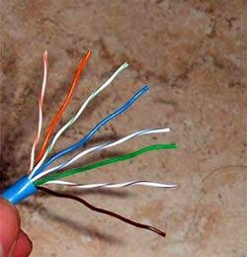

If you are making a crossover UTP cable that will directly connect two computers for file sharing arrange the colored cables in this order: white and orange; orange, white and green; blue, white and blue; green, white and brown; and finally brown.

Cut off the ends of the colored cables so that they are all the same length. Insert the colored cables into the open ports on the inside of the RJ-45 jack. Push the cables in until they are not able to move any farther. Insert the RJ-45 jack into the crimping hole on the wire stripping tool.

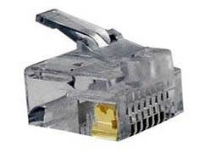

Push down on both handles of the crimping tool to lock the UTP cable into the RJ-45 jack. Repeat the entire cutting, arranging and crimping process with the other end of the UTP cable.

**Results:**

Crimper is the most essential tool and critical to the cable making process. Further, having a good cable tester can prevent and solve cable wiring configuration and installation problems. Ensure your RJ45 connectors are designed for the type of cable you are using (solid/stranded), as they have different types of teeth for piercing between multiple strands or around a solid single strand.

**Conclusion / Summary:**

The network cable is prepared and it is tested using the cable tester.